**The Work-Energy Theorem**

[Based on PASCO lab manual 32 Work-Energy Theorem, written by Jon Hanks]

**Pre-lab questions**

1. What is the goal of this experiment? What physics and general science concepts does this activity demonstrate?
2. What is the mathematical expression for the work-energy theorem?
3. Will changing the mass of the cart (while keeping everything else constant) change the kinetic energy of the cart?
4. Will changing the mass of the cart (while keeping everything else constant) change the maximum velocity of the cart?
5. What is the relationship between kinetic energy and velocity?

The goal of the experiment is to demonstrate the work-energy theorem by comparing the work done by an elastic cord to the increase in kinetic energy of a cart.

**Equipment:**

* Motion sensor
* Force sensor
* Rod and clamp
* String
* Elastic cord
* Elastic bumper
* Dynamics cart
* Track
* Masses
* Mass balance

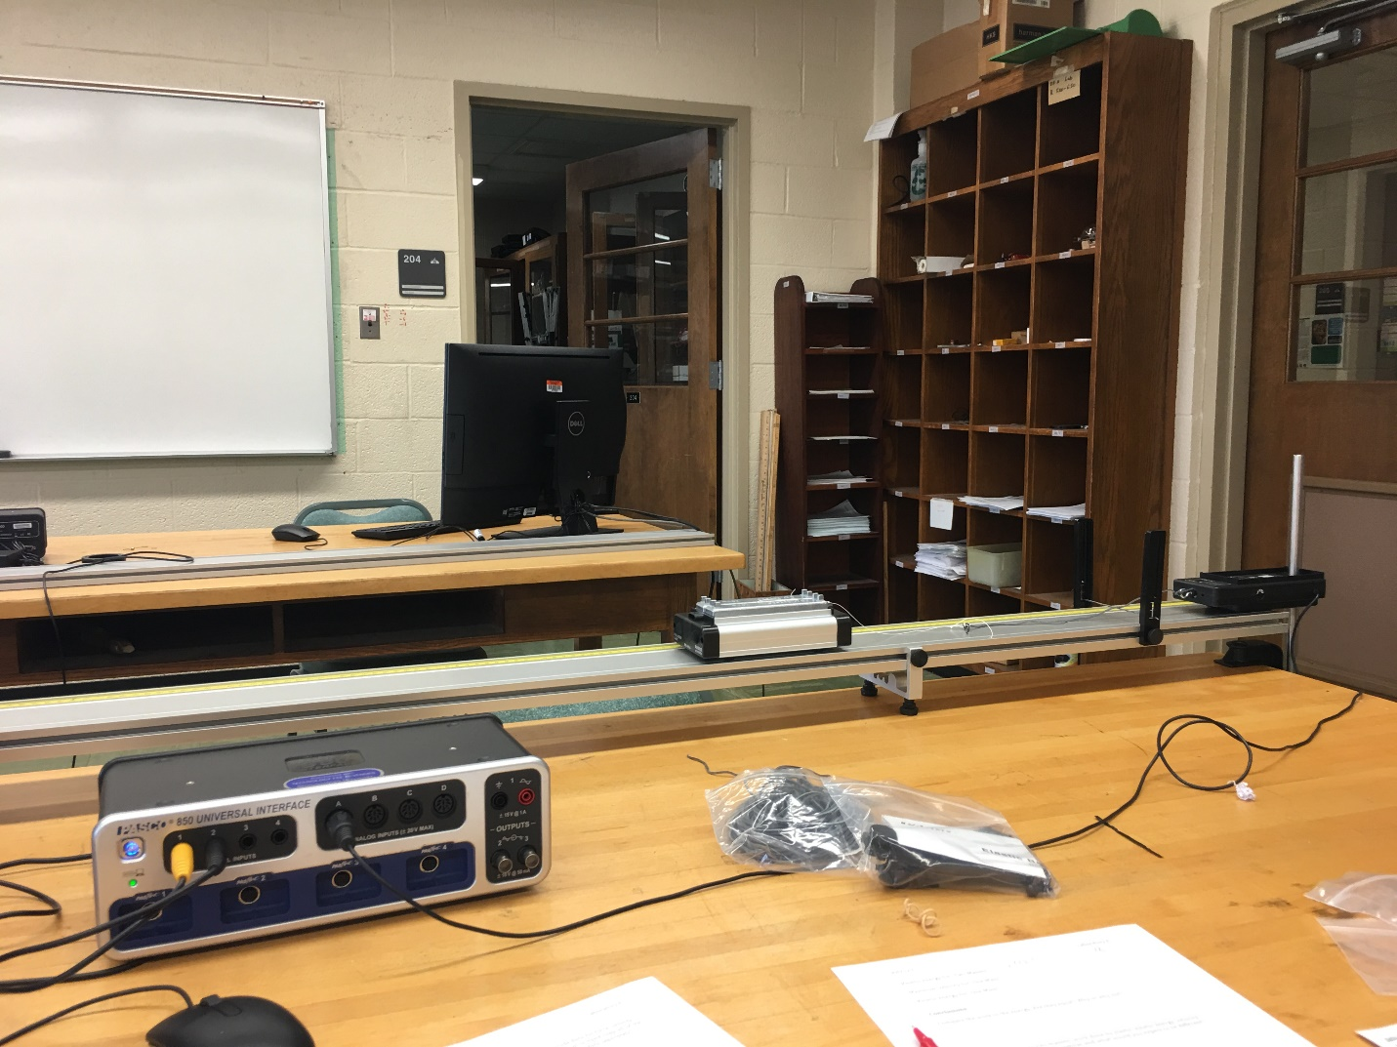

Figure 1: Equipment setup

**Introduction:**

The work-energy theorem states that the resulting change in the kinetic energy of an object is equal to the total work done on that object. This can be written as:

$$\begin{aligned}W_{net}=ΔKE\#\left(1\right)\end{aligned}$$

In this experiment, we will be using a stretched elastic cord to do work on a low-friction cart. We will calculate the work (*W*) done by the elastic cord by measuring the force (*F*) it applies over a given distance (*d*):

$$\begin{aligned}W=F∙d\#\left(2\right)\end{aligned}$$

However, this will not be simple multiplication because the restorative force of an elastic cord varies with the distance (*d*) the cord is stretched from equilibrium:

$$\begin{aligned}F=-kd\#\left(3\right)\end{aligned}$$

Here, *k* is known as the spring constant, and it is a function of the “stiffness” of the spring or elastic cord. The negative sign communicates that the force is “restorative” and pulls or pushes back to the equilibrium or “natural” length of the spring or elastic where you would say that $d=0$.

Because we cannot find work done by simple multiplication of an observed and measured force and distance, we will use a graph of many measurements of force and distance to find the work done. Finding the area under the curve of a force vs. position graph of this data will allow us to calculate a correct value for the work done by the elastic cord.

To demonstrate the work-energy theorem, we will also need to calculate the change in kinetic energy of the cart:

$$\begin{aligned}ΔKE={KE}_{f}-{KE}_{i}\#\left(4\right)\end{aligned}$$

Remember that kinetic energy is defined as:

$$\begin{aligned}KE=\frac{1}{2}mv^{2}\#\left(5\right)\end{aligned}$$

The cart is starting at rest for the time period that we are interested in, so we can say that the initial kinetic energy is zero. We calculate the change in kinetic energy by measuring both the mass and the maximum velocity of the cart.

We aim to demonstrate that the work (*W*) done by the elastic cord is equal to the increase in kinetic energy ($ΔKE$) of the cart. We will also look at the effect of changing the mass of the cart. Looking at equations (1) and (5), it is predicted that kinetic energy will remain the same for the same work done by the elastic cord, but that the square of velocity will increase with a decrease in mass.

**Experiment**

***Begin equipment set up as shown in figure 1:***

* Install the elastic bumper and adjustable feet.
* Attach the force sensor to the rod.
* Plug the force sensor into the PASCO interface.
* Press the zero button to tare the sensor when no force is applied.
* Attach the motion sensor and plug the sensor into the PASCO interface.
* Check that the motion sensor is set to the “cart” setting.
* Open PASCO Capstone software and set up hardware, paying attention to where the different sensors are connected to the interface.
* Use the default sample rate of 20 HZ for both sensors in the software.
* Create a graph of Velocity (y) vs. Time (x).
* Place both masses in the cart and measure the total mass of cart and additional masses using a balance. Record in the data section.
* Remove one mass from the cart and measure the total mass of one mass + cart using the balance. Record in the data section.

***Setting up the track so that the cart runs only slightly downhill will help to eliminate the effects of unwanted frictional forces. Carefully complete the following steps to help eliminate this possible source of error.***

***Adjust the level of the track as follows:***

* Place the cart on the track and give it a small push away from the motion sensor.
* Click on record just after pushing the cart.
* Stop recording before the cart hits the elastic bumper.
* Looking at your graph, determine whether your cart is moving at a constant speed.
* Using the screw feet, adjust the level of the track so that the cart is traveling at a constant speed (you will need to repeat steps 1-4 to verify this).

***Complete equipment set up:***

* Tie a short loop of string to the lower tab on the cart.
* Cut a 35 cm-long piece of elastic cord and tie it between the force sensor and the loop of string as shown.

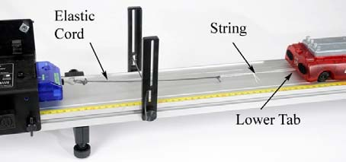

Figure 2: Elastic cord attachment [PASCO]

* Begin data collection:
  + In the PASCO Capstone software, change the data acquisition rate to 50 Hz.
  + Add a second plot area by clicking the new plot button  with force on the vertical axis.
  + Open the Recording Conditions and set the stop condition to “Measurement Based on Position Is Above 1.55 m.”

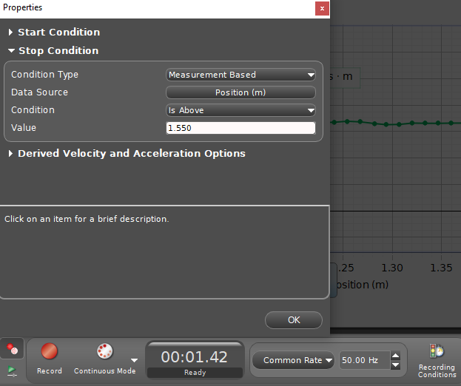

Figure 3: Screen capture of recording conditions in PASCO Capstone.

* + Pull the cart back, stretching the elastic cord, until the cart is a reasonable distance from the Motion Sensor. Make a note of your starting point. *Keep your hand to the middle of the cart, so that the sensor is measuring the distance to the end of the cart, not your body.*
  + Click Record and then release the cart. The stop condition should automatically end recording before the cart reached the elastic bumper.
  + Check that your force data is positive. Check that you have good, smooth velocity data. You should clearly see a maximum in velocity before the recording stops.

*Troubleshooting:*

* *If your force data is not positive, open Data Summary and click on the properties (gear) icon for the Force Sensor. Check the box to change the sign.*
* *If you do not see a clear maximum velocity, you may need to adjust the automatic stop condition.*
  + When you are satisfied with a run, rename it “Two Masses”.
  + Remove one mass from the cart and repeat the data collection procedure. When satisfied, rename this run “One Mass”.

**Data:**

[include proper units]

Mass of cart + 2 masses: ______________________________

Mass of cart + 1 mass: ________________________________

*Data tables are included in PASCO software. They will include data for force, velocity, and position. Because the sample rate is 50 Hz, it is impractical to hand-copy all of the data into a table in this procedure. Save and submit graphs of one example run of your PASCO data separately.*

**Computations and Analysis:**

***Analyze the work done by the elastic string:***

* Using the PASCO Capstone software, create a graph of force vs. position for the “Two Masses” run.

For an elastic material following Hooke’s Law ($F=-kx$), the graph of F vs. x is a straight line. The slope of that line is the spring constant (*k*). Does the elastic cord in this experiment appear to follow Hooke’s Law?

* Highlight the relevant data, and find the area under the curve.

What is the physical significance of the area? What are the correct units?

* Repeat the process for the run titled “One Mass”.

Work done by elastic for “Two Masses”: __________________________________________

Work done by elastic for “One Mass”: __________________________________________

***Analyze the change in kinetic energy of the cart:***

* Using the PASCO Capstone software, create a graph of velocity vs. position for the “Two Masses” run.
* Highlight the relevant data, and use the statistics tool or coordinates tool  to find the maximum velocity. Record this value below.
* Use the maximum velocity and the mass of the cart to calculate the kinetic energy of the cart. Record this data below.
* Repeat the process to find the kinetic energy for the run titled “One Mass”.

Maximum velocity for “Two Masses”: __________________________________________

Kinetic energy for “Two Masses”: __________________________________________

Maximum velocity for “One Mass”: __________________________________________

Kinetic energy for “One Mass”: __________________________________________

**Conclusions:**

Compare the work to the energy. Are they equal? Why or why not?

Compare one mass to two masses: work done by elastic, kinetic energy, velocity. what would you expect to be similar and what would you expect to be different?

**Sources of errors:**